Name: Puna Poudel

Assignment: Module 6.2

Due Date: 6/03/2024

Professor: Chandra Bobba

Github url: <https://github.com/punaram14/csd-310.git>

Step 5:

Running the sql script

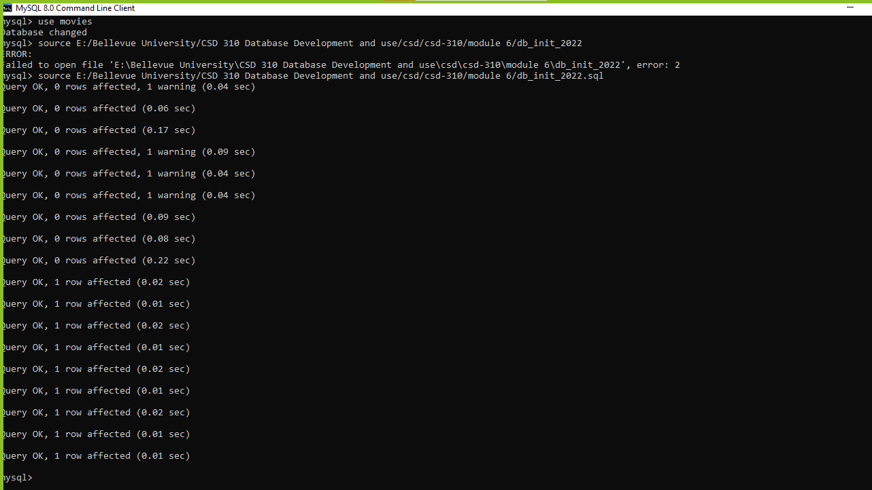

Step 6:

Showing tables

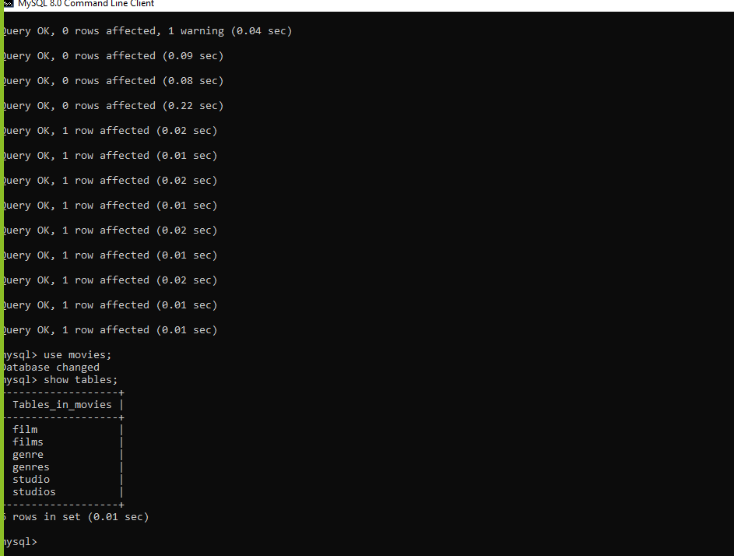

Step 7:

Code for the connection.

import mysql.connector  
  
config = {  
 'user': 'root',  
 'password': 'root',  
 'host': '127.0.0.1',  
 'database': 'movies',  
 'raise_on_warnings': True  
}  
  
cnx = mysql.connector.connect(**config)  
print("connected")  
cursor = cnx.cursor();  
cursor.execute("show databases");  
for x in cursor:  
 print(x)  
  
  
cnx.close()

Output screenshot

